SUJAL SHARMA
Cloud Engineer | DevOps Engineer | Platform Engineer
9109928735 | sujalsharma151@gmail.com
LinkedIn: linkedin.com/in/sujal-sharma-b441ba23b | GitHub: github.com/sujalsharmaa
PROFESSIONAL SUMMARY
AWS Certified Developer Associate and HashiCorp Terraform Associate with hands-on experience building cloud-native applications, Kubernetes platforms, CI/CD pipelines, GitOps workflows, microservices, observability stacks, and scalable backend systems. Skilled in AWS, Terraform, Docker, Kubernetes, Jenkins, Argo CD, Istio, Prometheus, Grafana, Node.js, PostgreSQL, Redis, and Kafka.
TECHNICAL SKILLS
Cloud: AWS (EKS, EC2, IAM, S3, CloudFront, Route53, Lambda, RDS, CloudWatch,Lambda,API Gateway)
DevOps: Linux,Bash, Docker, Kubernetes, Terraform, Jenkins, Argo CD, Istio,Nginx
Observability: Prometheus, Grafana,Kiali
Backend: Node.js, Express.js, Spring Boot, REST APIs, Microservices
Databases: PostgreSQL, MongoDB, Redis, ChromaDB,ElasticSearch,DynamoDB
Programming: JavaScript, Java, Python
Messaging: Kafka, Redis Pub/sub
CERTIFICATIONS
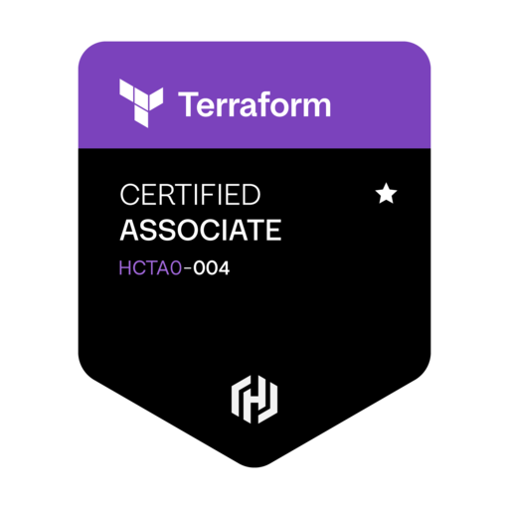

• AWS Certified Developer – Associate (2026)
• HashiCorp Certified: Terraform Associate (004) (2026)
PROJECTS
CloudSync – Cloud-Native Storage Platform (https://drive.sujalsharma.in)
• Designed a distributed microservices architecture for file storage and processing.
• Implemented reactive uploads, AI-powered content moderation, metadata extraction, and quota validation.
• Leveraged AWS, Kubernetes, Docker, Kafka, Redis, PostgreSQL, and GitOps deployment practices.
SheetWise – Real-Time Collaborative Spreadsheet Platform (https://sujalsharma.in) (https://youtu.be/WFE_2O74kj8)
• Built an Excel/Google Sheets-inspired application with collaborative editing and AI spreadsheet assistent
• Developed scalable backend services using Node.js, PostgreSQL, Redis, and WebSockets.
• Designed for cloud deployment, observability, and horizontal scalability.
YouTube Comments Downloader https://comments.sujalsharma.in)
• Developed a backend system to collect, process, and export large volumes of YouTube comments.
• Built API integrations and automated data-processing workflows.
TECHNICAL WRITING
• PainPoints of Maneuvering Distributed Microservices in CloudSync with Limited Budget (Medium)
• The Engineering Pain Points Behind Building Excel Clone SheetWise (Medium)
EDUCATION
Bachelor of Computer Applications (BCA) | Shri Vaishnav Institute of Management, DAVV Indore
CGPA: 7.95 | First Division

